User Manual
Project HomerWeb
v1.1
(Updated from Team HomerWeb’s User Manual)

DVL Holdings
Team BoardsReview (Georgia Institute of Technology)

Kimberly Wong Derek Tatum
Matt Remmele Jared Caldwell Mikhail Lovell

Table of Contents
1 Welcome 4
2 User Account Operations 5
2.1 Registering an Account 5
2.2 Logging In 5
2.3 Forgot Password 6
3 User Announcements 7
3.1 Viewing the Announcements 7
4 User Courses/Lectures 8
4.1 Viewing the List of Courses 8
4.2 Viewing the List of Lectures for a Course 8
4.3 Lecture Information/Resources 9
4.4 Lecture Resources/Video 10
4.5 Lecture Resources/PowerPoint 11
5 User Subscriptions 12
5.1 Extending a Subscription 12
5.2 Purchasing a new Subscription 13
6 User Profile 14
6.1 Editing a User Profile 14
7 Admin Panel 15
7.1 Accessing the Admin Panel 15
7.2 Admin Panel Home 15
8 Managing Users 17
8.1 Viewing User list 17
8.2 Add New User 18
8.3 Add User From Excel File 18
8.4 Edit User 19
9 Managing Courses 21
9.1 Viewing Course List 21
9.2 Add New Course 21
9.3 Edit Course Information 22
9.4 Add Course Admin 22
9.5 Remove Course Admin 22
9.6 Add Course Subscription 23
9.7 Delete Course Subscription 23
9.8 Edit Course Subscription 24
9.9 View Course Schedule 24
9.10 Add Schedule Item 25
10 Templating 26
10.1 Theme the Main page 26
10.2 Change the “About Us” Text 27

1 Welcome

Welcome to the user manual of DVL Holdings Course Management System. In this manual, you will find all the necessary instructions on how to use this product and/or services. In the coming pages, there will be a complete guide with screenshots that will show you the various tasks from logging in to the website to customizing your very own classes and lectures. Please refer to the table of contents to help locate your specific tasks.
Project Homerweb is still in development, therefore, this document is subject to changes in future versions.

2 User Account Operations
2.1 Registering an account
To register for an account, first click on the tab at the top of the screen labeled “Login | Register”. The tab will drop down and display two sections: “Member Login” & “Not a Member Yet?”. Next, find the link that says “Click here to Register!”. This link should be located in the “Not a Member Yet?” section.
When registering, you must provide a valid and active e-mail account that you have access to. Your login information will be sent automatically to this registered e-mail address.
See the example in figure 1.
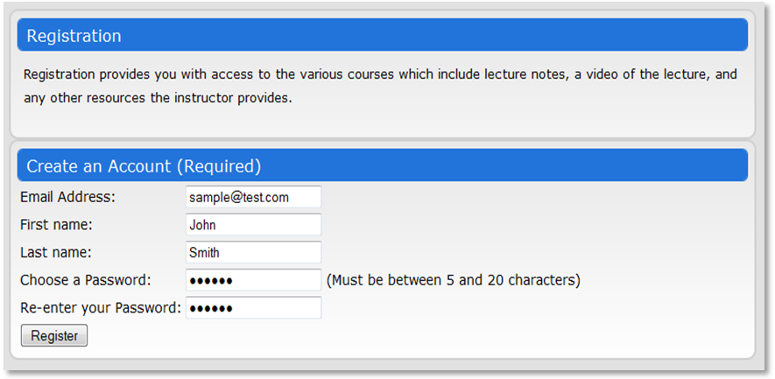
Figure 1

2.2 Logging In
To log into the site, find the login tab at the top of the screen. This login box requires a valid and active e-mail address and a password. Without both, a user cannot log into the site.
See the example in figures 2 & 3.
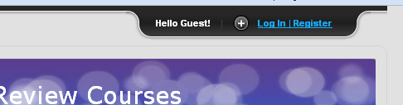
Figure 2

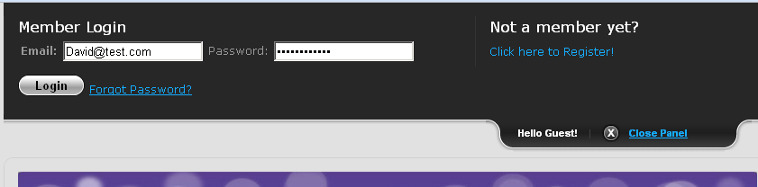
Figure 3

2.3 Forgot Password
If you have forgotten your password, please visit the “Forgot Password” link. The link is near beside the Login button in the dropdown login bar.
To recover your password, simply enter in the e-mail address that you registered the account with. Your password will then be reset and e-mailed to the specified e-mail address.
See the example in figure 3.
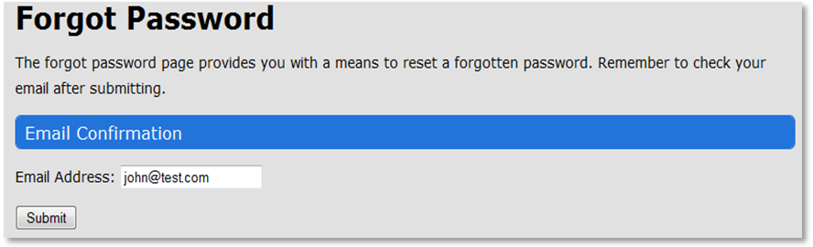
Figure 3

3 User Announcements
3.1 Viewing the Announcements
Once logged in, you will be brought to the “Home” tab, which displays the announcements for the courses that has posted an announcement. To view any particular announcements, simply click on the announcement link for that course.
The left module box displays the list of announcements for a particular course. The right module box displays the announcements for the currently selected course.
See the example in figure 4.
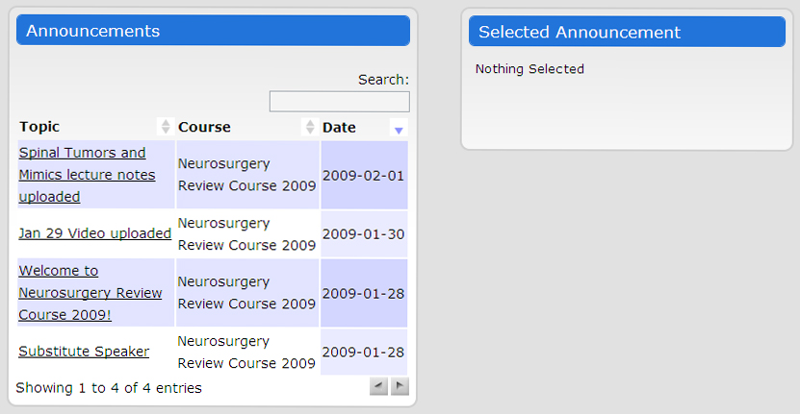
Figure 4
4 User Courses/Lectures
4.1 Viewing the List of Courses
To view the list of courses that you have registered for, click on the “Courses” tab. This will display the list of courses that you have access to, along with a brief description and their state date and end date.
4.2 Viewing the List of Lectures for a Course
Once you are in the “Courses” tab, if you want to view all the lectures pertaining to a specific course, simply click on that course link under the Course column.
Once a course link has been clicked, the page will now display a list of lectures for that course. The table will have the list of lectures along with the speaker for that lecture and the date and time it begins.
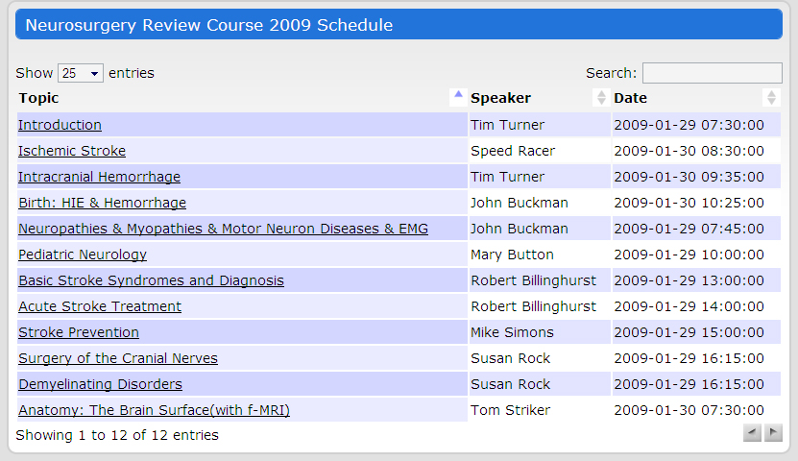
Figure 5
To get more information about a lecture, choose a lecture and click the link. See 4.3 for more information.

4.3 Lecture Information/Resources
To get information about a lecture, you must have completed the steps in 4.2. Once completed, the page will display the lecture name and various information such as the date, time, and the instructor. The resources for that lecture will be displayed within a table.
See the example in figure 6.

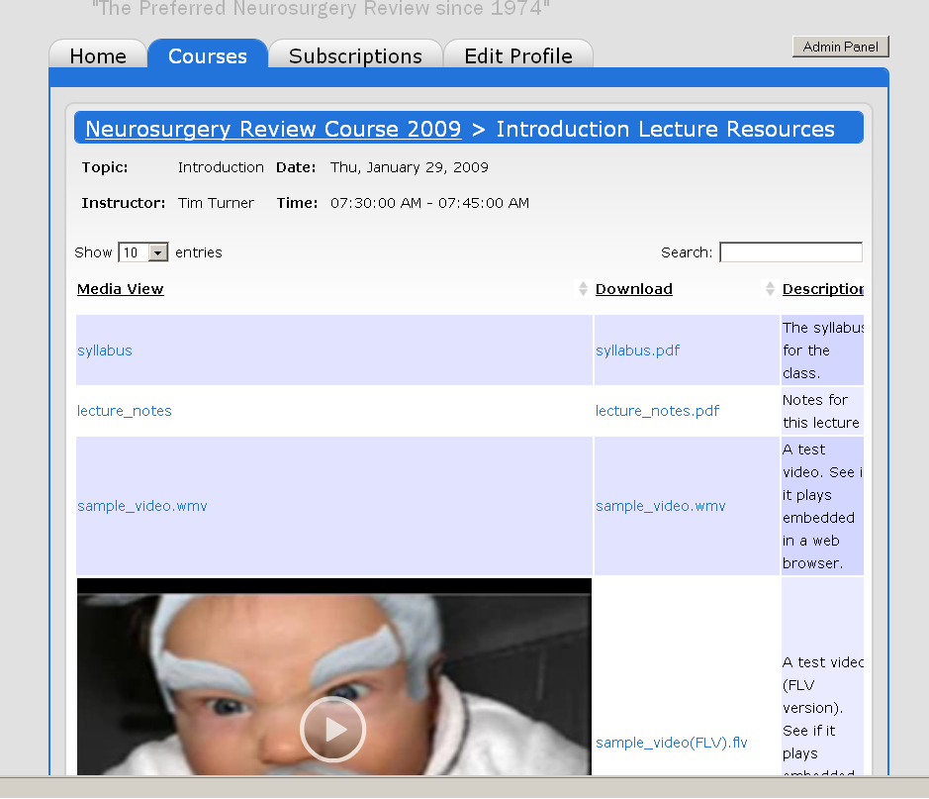
Figure 6

4.4 Lecture Resources/Video
To view a video lecture, simply click on the embedded video on the page. To watch the video, the user first must have the Flash plug-in installed on their computer’s web browser. To download the video, the video must first have been set to be downloadable when it was uploaded to the website. If it is indeed downloadable, click on the link to the right of the resource.
See the example in figure 7.

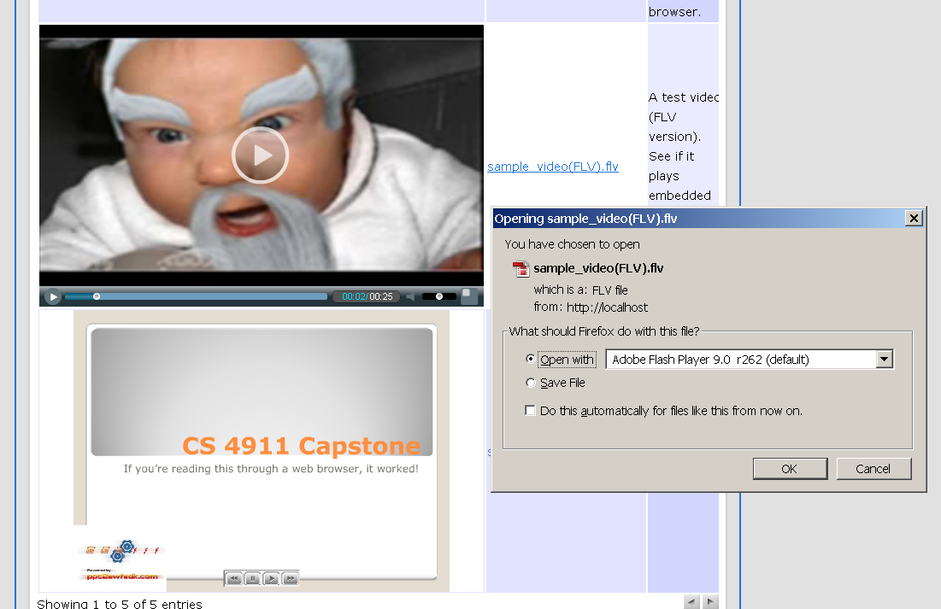
Figure 7

4.5 Lecture Resources/PowerPoint
If a PowerPoint exists for a lecture, the table of resources will display them. To view the presentation, simply scroll down to the embedded presentation and click the forward and back buttons to go through the slides. If the PowerPoint presentation is downloadable, users can simply click on the link that has the file name to download it.
Currently, only .ppt files can be converted and embedded.
See the example in figure 8.
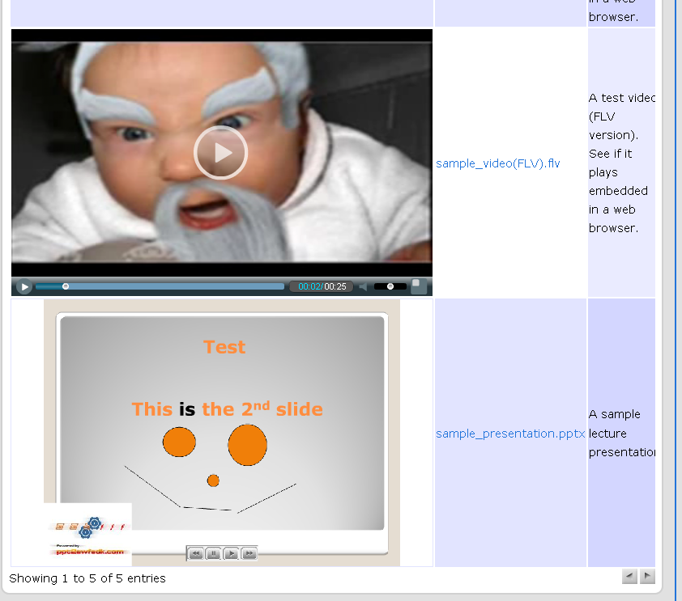
Figure 8

5 User Subscriptions
5.1 Extending a Subscription
To extend a subscription, the user must visit the subscriptions tab and select the course that they want to extend. The subscriptions page will display various tables.
The subscription table:
This table will display all the current subscriptions that the user has and ones that have expired.
To extend a subscription, click on the “Extend” button besides the subscription that you wish to extend.
Upon doing so, this will bring you to a new page where you can extend your subscription for that particular course.
See the example in figure 9.

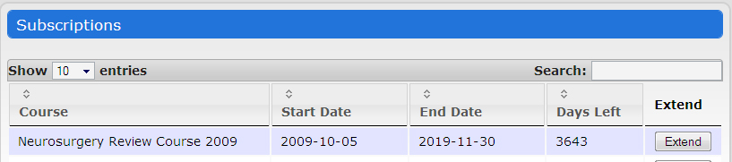
Figure 9

5.2 Purchasing a new Subscription
To purchase a new subscription, the user has to be in the “Subscriptions” tab. This tab will display various tables. The table that is relevant is the “Purchase New Courses” table.
The Purchase New Course table:
This table will be displayed directly below the “Subscriptions” table. In this purchase new course table, the user can pick a course that is currently available and register for it.
To do so, simply click the “Purchase” button next to the course. Upon doing so, a new page will be displayed that will ask if you to proceed with the process.
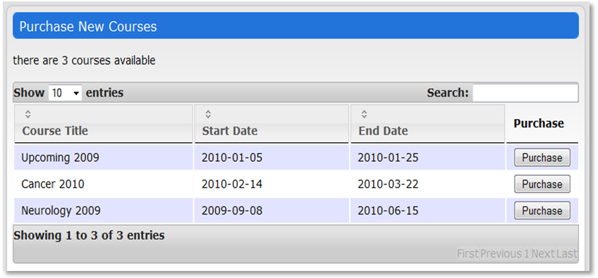
See the example in figure 10.
Figure 10

6 User Profile
6.1 Editing a User Profile
A user can edit his or her profile but visiting the “Edit Profile” tab. This page will display various fields that the user can edit about his or herself. Once completed, simply click the “Save Changes” button to complete the process.
See the example in figure 11.
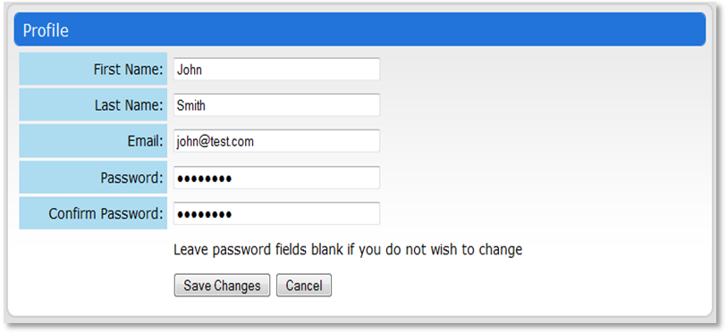
Figure 11

7 Admin Panel
7.1 Accessing the Admin Panel
Admins (site, course, and lecture) will see a button in the upper right corner of the User pages that will allow them to access the Admin Panel.
See the example in figure 12.
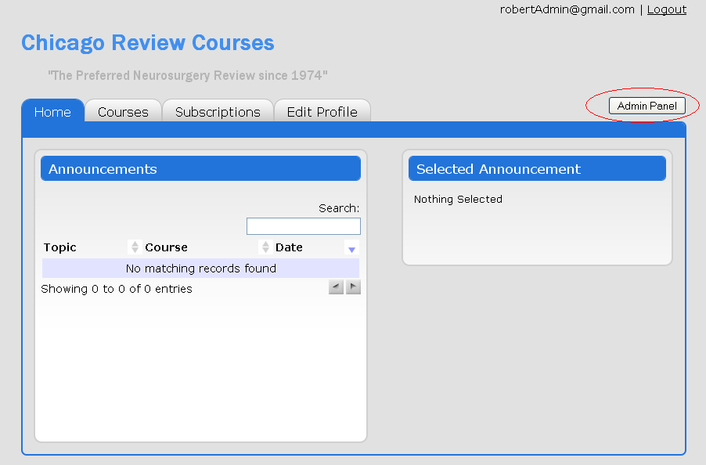
Figure 12

7.2 Admin Panel Home
The Admin Panel Home will appear differently depending on whether the user is a site admin, or a course or lecture admin. Site admins will be able to access Users, Courses, and Settings controls. Course and lecture admins will only be able to access Course controls, and they will have limitations within that category.
See the example in figures 13 & 14.

Site Admin Home:
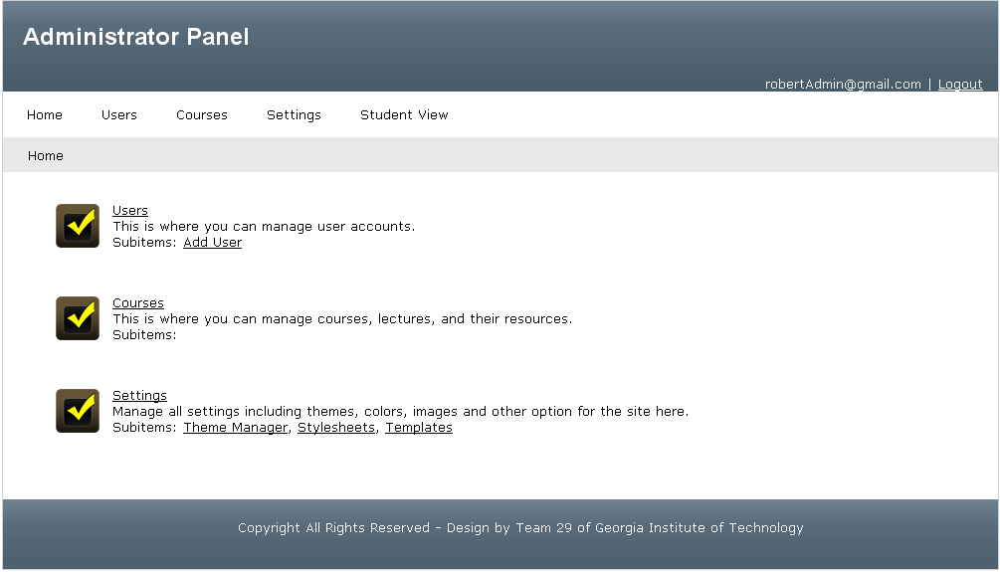
Figure 13

Course and/or Lecture Admin Home:
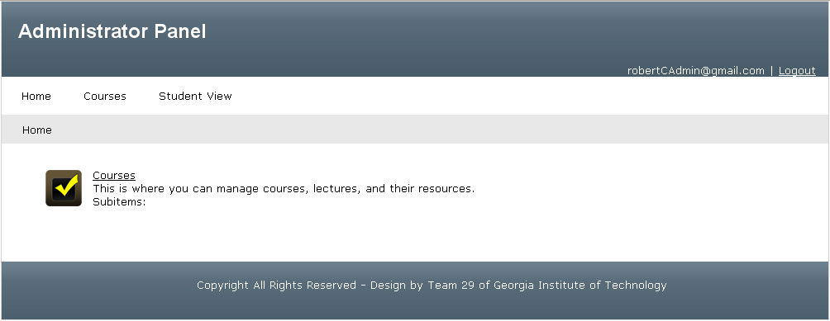
Figure 14

8 Managing Users
8.1 Viewing User list
After navigating to the Users section, you will see a table of users. You can increase the number of rows shown, page through the table, sort the table, or search the table using the drop down list, buttons, or search box.
See the example in figure 15.
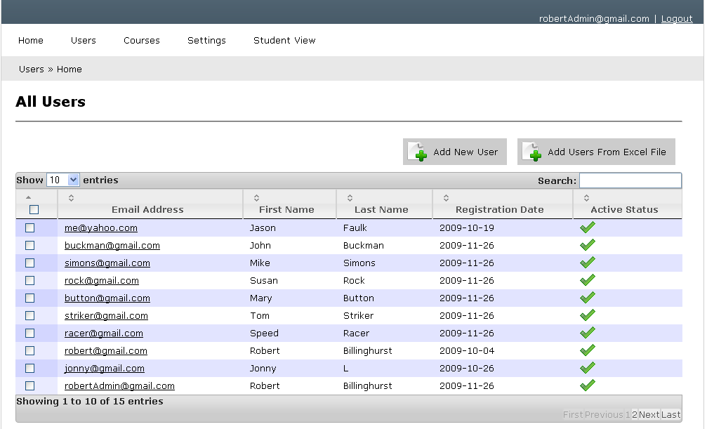
Figure 15

8.2 Add New User
Click on the Add New User button to add a user. You must enter a valid email address, first name, last name, and password. You can choose to either randomly generate a password or manually type in a password. You can also send an email to the created account if you want, and you can send them their account name and password using {email} and {password} to represent the email and password chosen.
See the example in figure 16.
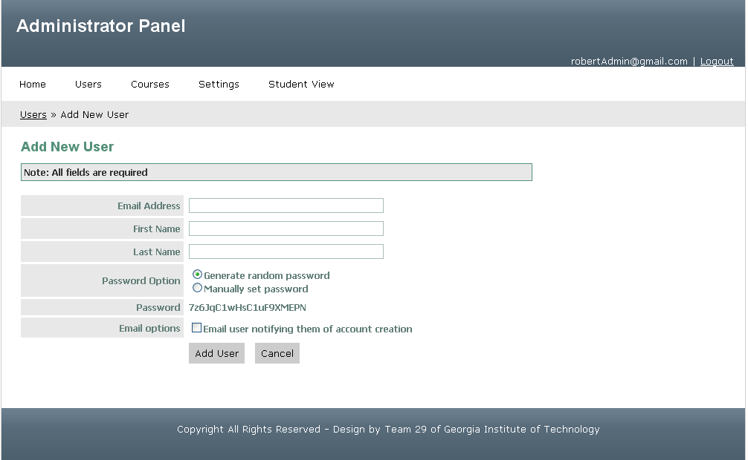
Figure 16

8.3 Add Users From Excel File
Click on the Add Users From Excel File button, and then select an excel spreadsheet. The spreadsheet uploaded should have 3 columns that are in this order: Email, first name, and last name. Do not insert any headers for the columns, only have a spreadsheet of data. The password for all users will be set to testing123.

8.4 Edit User
In the User View, click on a user email to edit that user.
See the example in figure 17.
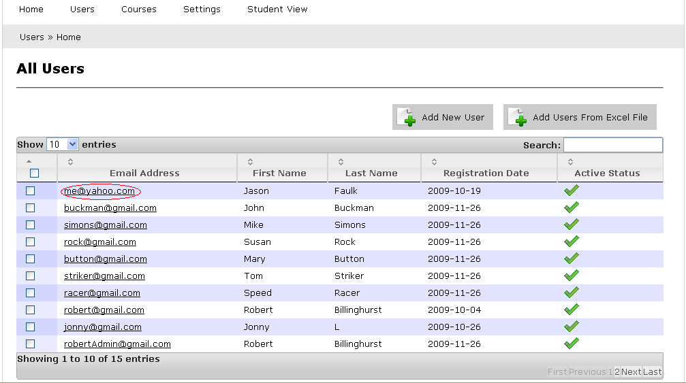
Figure 17
You are redirected to the Edit User page. Update fields as needed and click Save Changes. You can change the active status here.
See the example in figure 18.
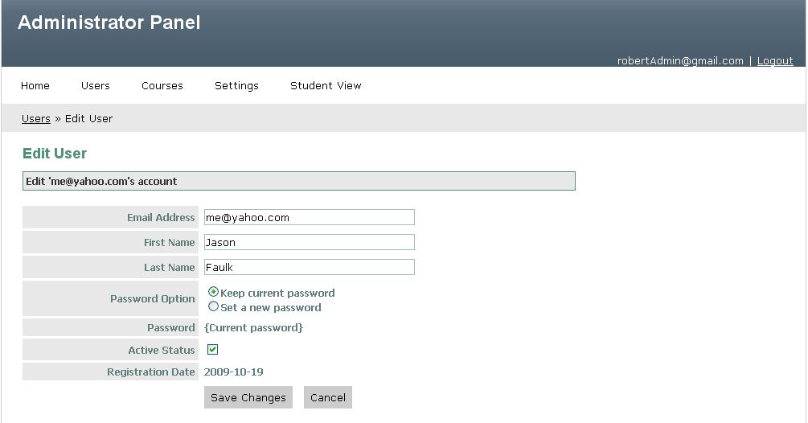
Figure 18

9 Managing Courses
9.1 Viewing Course list
After navigating to the Courses section, you will see a table of courses. You can increase the number of rows shown, page through the table, sort the table, or search the table using the drop down list, buttons, or search box.
9.2 Add New Course
To add a new course, click the “Add New Course” button at the top of the table. Upon doing so, a new page will be display like the one in the figure below. Simply fill in the required information for each field and click “Add Course” when you’re done.
See the example in figure 19.
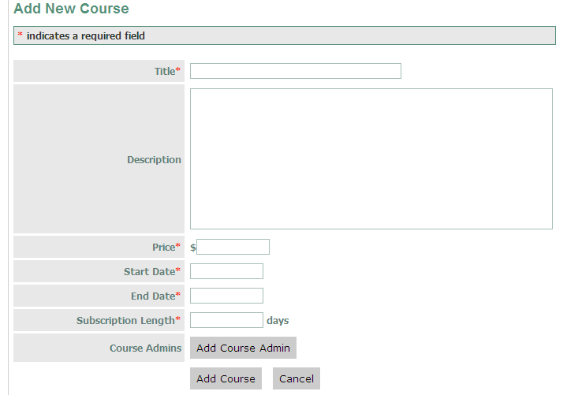
Figure 19

9.3 Edit Course Information
To edit a currently existing course, choose the course that you want to edit from the course table and click on it. After clicking on it, a page very much like the one in figure 19 will be displayed with the current values for that course. Edit the necessary information and click the “Save Changes” button.
9.4 Add Course Admin
To add an admin to a course, choose the course that you want to edit and click on it from the course tables. Navigate to the “Course Admins” tab while still under the “Edit Course” option. A new page will be displayed much like the one in figure 17.
See the example in figure 20.

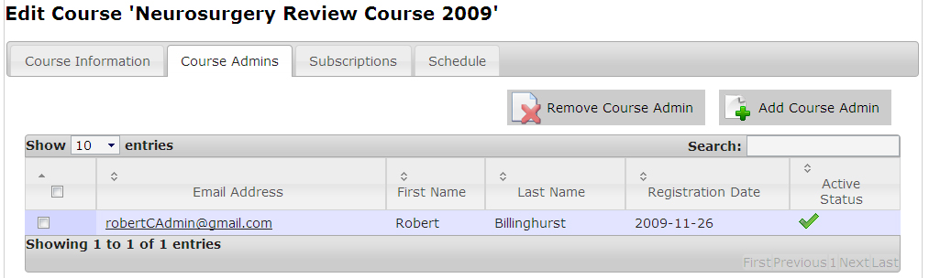
Figure 20
Once the “Add Course Admin” button is clicked, a dialog box will popup to ask you to choose from a list of users who will be the admin.

9.5 Remove Course Admin
To remove a course admin, refer to figure 20 above. You will have to choose the admins that you want to remove and tick the checkbox to the left of the name. After doing so, click on the “Remove Course Admin” button and that selected admin will be removed from the currently selected course.
9.6 Add Course Subscription
To add a user subscription to a particular course, click on the “Subscriptions” tab. In the subscriptions tab, you will be able to add a subscription by clicking on the “Add Subscription” button. A popup window will appear that will ask you to choose the user that you want to add the subscription to.
See the example in figure 21.
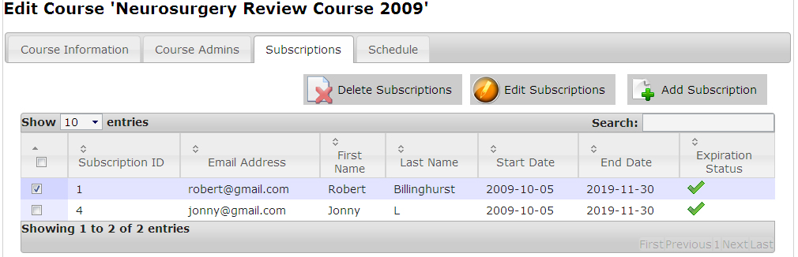
Figure 21

9.7 Delete Course Subscription
To delete a subscription from a course, select the user that you want to subscription to be deleted for and click the “Delete Subscription” button. Refer to Figure 21 for a visual guide.

9.8 Edit Course Subscription
To edit a subscription for a specific course, choose the user that you want to edit the subscription for and click the “Edit Subscription” button. Upon clicking the button, a popup window will appear that will allow you to edit the subscription.
See the example in figure 22.
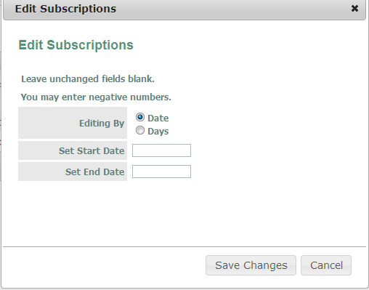
Figure 22
9.9 View Course Schedule
To view a schedule for a particular course, click on the “Schedule” button while being under the editing course page.
The Schedule tab will display a table with all the lectures. To edit the schedule for a particular lecture, click on the lecture that you want to edit and a new page will be displayed that will allow you to edit the schedule fields.
See the example in figure 23.
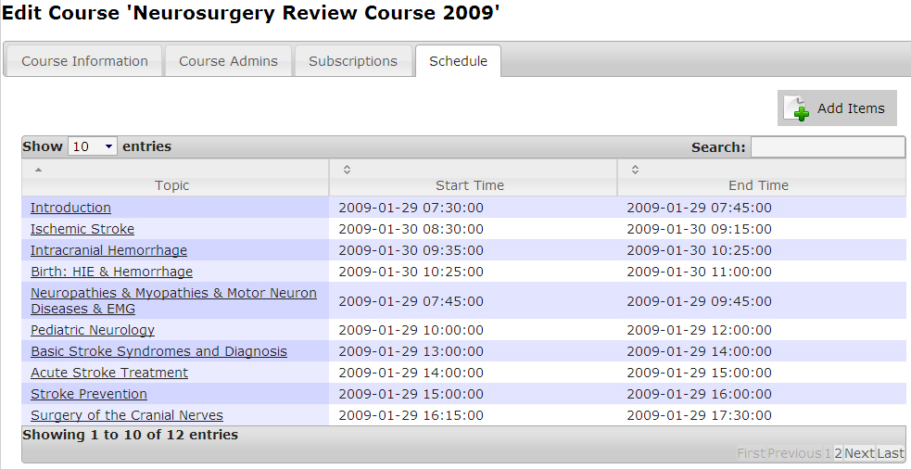
Figure 23

9.10 Add Schedule Item
To add an item to the schedule, click on the “Add Items” button under the “Schedule” tab. Refer to figure 23 for reference. Upon clicking on the button, a popup window will appear that will allow you add an item to the schedule.

10 Templating
10.1 Theme the Main page
To edit colors and images for the main page, click on the “Settings” tab from the main admin panel menu. A new page will be displayed where the user can edit the colors and images of the Main page. After finishing changing the settings, click the Save Changes button to update the settings.
See the example in figure 24.

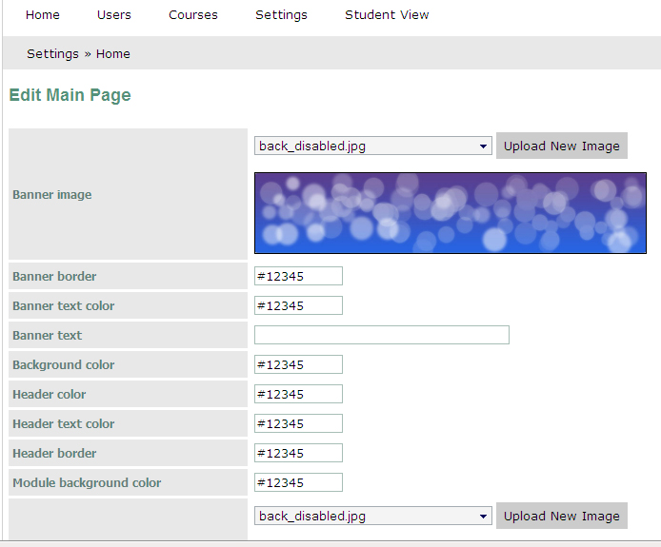
Figure 24

10.2 Change the “About Us” text
To edit the text for the “About Us” page, click on the “Settings” tab from the main admin panel menu. The entry for “About Us” can be found at the bottom of the page. After changing the entry, press the Save Changes button to update the page.
See the example in figure 25.

